Main Concept:

‘this’ is the NEWLY CREATED object in a constructor invocation

Context of a constructor invocation

* The newly created object itself

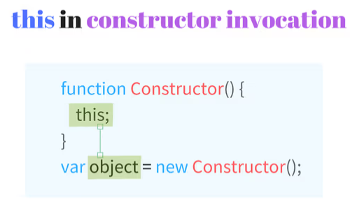

Example Code:

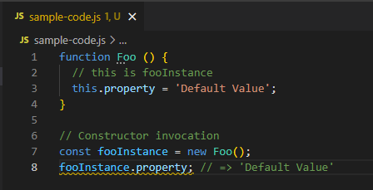

ES2015 class syntax

